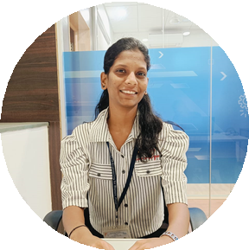
KIRAN DHAMANDE
A highly motivated and dedicated Electronic and Telecommunication student looking for a position in an esteemed organization where I can utilize my skills for the growth of the organization.
BTech Undergraduate ( Electronic and Telecommunication )

EDUCATION

MKSSS's Cummins College of Engineering for Women, Pune 2022-2026
CGPA - 7.7 (current)
Higher Secondary Education Sikshan Maharshi Late Shrihari Jiwatode College, Chandrapur HSC Board - 90.33% Secondary Education
St. Michael's English School, Chandrapur
SSC Board - 89.20%

SKILLS HIGHLIGHTS
Basics of C, C++ Basic of Java
Standard HTML DBMS
MS office tools - Word, PowerPoint, Excel

SOFT SKILLS

Teamwork Adaptability Fast learner
Leadership
Time management
Kiran.dhamande@cumminscollge.in

+91 9529356344
Chandrapur, Maharashtra DOB: 16/01/2003

PROJECTS
ONLINE SHOPPING SYSTEM
This project involves building a console-based Java application that simulates an online shopping experience. It uses Object-Oriented Programming to structure core features and JDBC to interact with a relational database.
AUTONOMOUS FIRE DETECTION AND EXTINGUISHING SYSTEM

This project involves designing and developing a robotic system capable of detecting and extinguishing fire autonomously. It uses flame sensors for fire detection and controls movement and water spraying using Arduino-based logic.

ACCOMPLISHMENTS

Made into top 5 teams data structure hackathon in ccoew technical fest‘23
Participated in Katalyst Hackathon

LANGUAGES

Project management English Hindi
Marathi

